**Assignment 5**

AIM : To find a procedure to launch virtual machine using trystack (online openstack demo version).

PROCEDURE: OpenStack is an open-source software cloud computing platform. OpenStack is primarily used for deploying an infrastructure as a service (IaaS) solution like Amazon Web Service (AWS). TryStack is the easiest and free way to do it.

Step 1: Prepare the environment for installing OpenStack:

Run the following commands and you will be done with it to bring all your packages to the latest version and install git so that we can clone OpenStack to our Linux machine

Command:

* sudo apt-get update
* sudo apt-get upgrade
* sudo apt-get dist-upgrade
* sudo apt-get install git -y
* sudo reboot

Step 2: Download and Install OpenStack

After your virtual machine is done with a reboot, you are now ready to install OpenStack. Normally OpenStack runs under non-root user with sudo privileges. We can easily createone to start with using:

Create the user named as “stack”

sudouseradd -s /bin/bash -d /opt/stack -m stack

Now let us give this user sudo privileges using:

echo"stack ALL=(ALL) NOPASSWD: ALL"|sudotee/etc/sudoers.d/stack

We now have to log in as user ―stack to proceed with our installation as

sudosu–stack Start with the installation of openstack by downloading the required material.

git clone https://git.openstack.org/openstackdev/devstack# cd to the cloned directory cddevstack

Normally during installing it will ask you to set various passwords, you can automate this process by creating a file in your current directory named ―local.conf. Save and exit the following file, this will automate the installation process.

# create the file $ nanolocal.conf

# now paste following contents in the file

[[local|localrc]]

ADMIN_PASSWORD=secret

DATABASE_PASSWORD=$ADMIN_PASSWORD

RABBIT_PASSWORD=$ADMIN_PASSWORD

SERVICE_PASSWORD=$ADMIN_PASSWORD

We are now ready to run the installation script. Installation script can be launched using the command: ./stack.sh

Once installation is complete below screenshot will be visible.

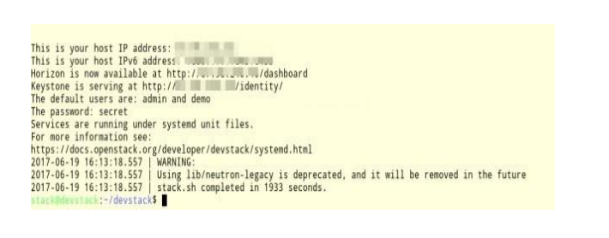

OpenStack dashboard can now be accessed at: http://<IP Address>/dashboard/

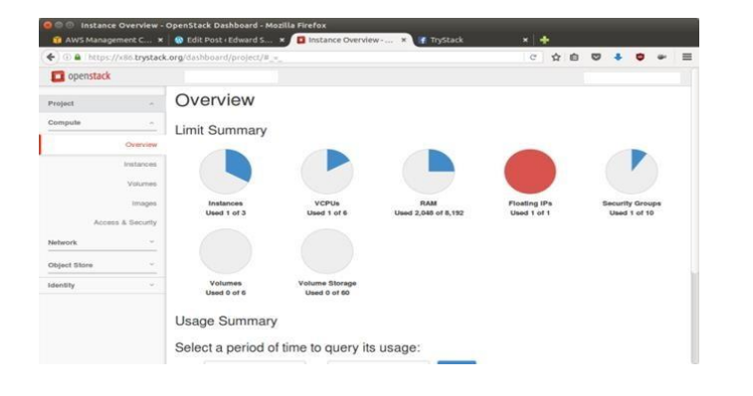

Step 3: Create Network

Note: Please remember that without having a network, you cannot launch an instance/virtual machine.

After you are logged into the OpenStack Dashboard it will look something like this:

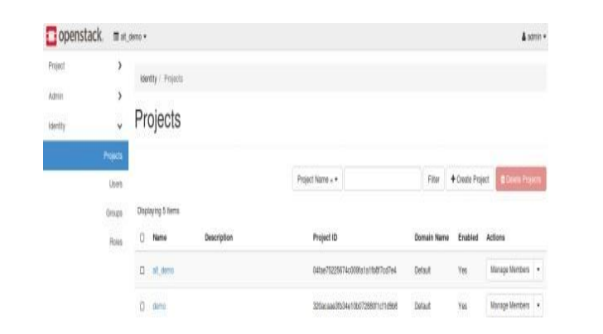

We need to create a network that virtual machine can use. For now, it will just be a dummy network: Steps:

* Click the Project Drop Down.
* Click the Network Drop Down.
* From network Drop Down select Networks, and this window will open that you see on the right side.
* Finally, click Create Network.

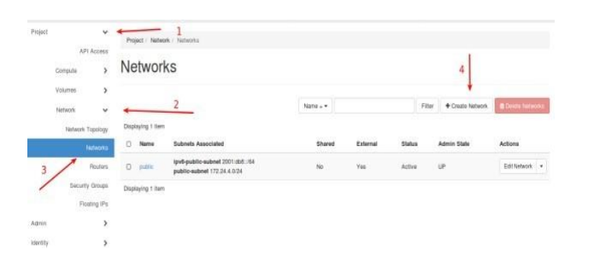

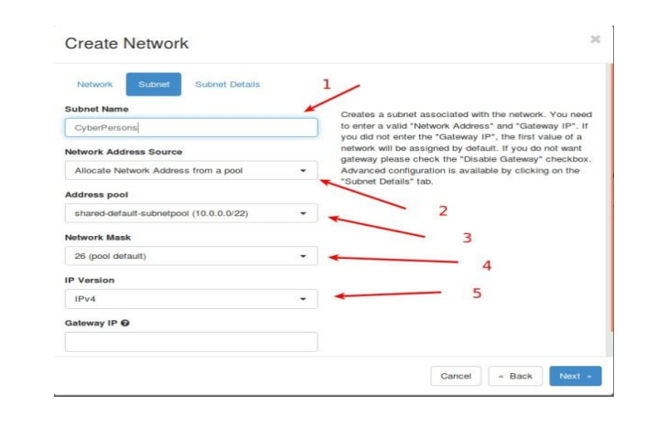

Once all these things are done, click ―Next.

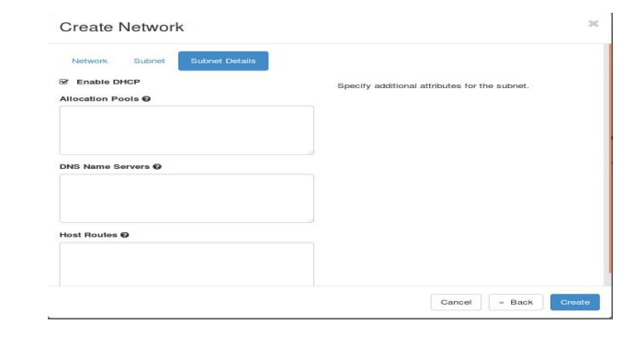

Step 4: Create Virtual Machine/Instance

After the network is created, we are now ready to create our very first virtual machine.

Step:

1. Click on ―Project drop down.

2. Inside project click ―Compute drop down.

3. Under compute you have four options, since we are interested in creating an instance; you have to click on ―Instance.

4. Finally, click ―Lunch Instance.

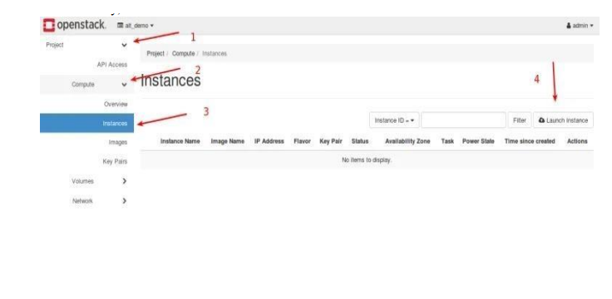

Step 5: Access Virtual Machine Console

Once you click ―Launch Instance‖ it will take OpenStack few seconds to create your virtual machine. Once ready you can access the console to see how the command line of your first virtual machine looks like.

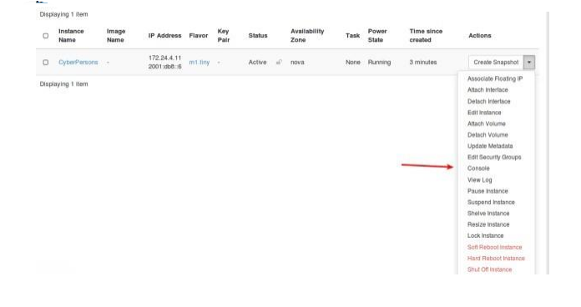

Click on ―Console and OpenStack will take you to the console of the virtual machine. The console will look something like this:

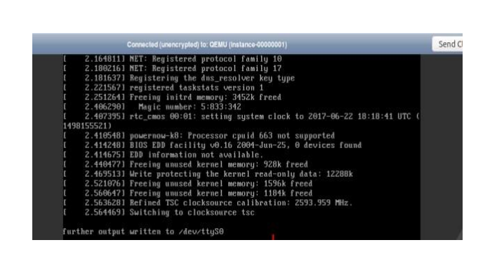

RESULT: The procedure for find a procedure to launch virtual machine using trystack (online openstack demo version) was learned and verified successfully .